# AI PLANT DISEASE DETECTION

# A PROJECT REPORT

***Submitted by***

**Rakesh VS 210701205**

**Jinesh K 210701508**

***in partial fulfillment for the award of the degree of***

**BACHELOR OF ENGINEERING IN COMPUTER SCIENCE RAJALAKSHMI ENGINEERING COLLEGE THANDALAM**



**ANNA UNIVERSITY CHENNAI 600 025 DECEMBER-2023**

**BONAFIDE CERTIFICATE**

This is to certify that this project report titled “**AI PLANT DISEASE DETECTION**” is the bonafide work of “Rakesh VS 210701205,Jinesh K 210701522” who carried out the project work under my supervision.

**SIGNATURE**

**Dr. RAKESH KUMAR M, M.E., Ph.D.,**

**Assistant Professor**

Department of Computer Science and Engineering Rajalakshmi Engineering College

Chennai - 602 105

This project report is submitted via viva voce examination to be held on ……

. at Rajalakshmi Engineering College, Thandalam.

**EXTERNAL EXAMINER INTERNAL EXAMINER**

# ACKNOWLEDGEMENT

First and foremost, I acknowledge the amazing Grace of God Almighty, who blessed my efforts and enabled me to complete this thesis in good health, mind, and spirit.

I am grateful to my Chairman **Mr. S. Meganathan**, Chairperson **Dr. Thangam Meganathan**, Vice Chairman **Mr. M. Abhay Shankar** for their enthusiastic motivation, which inspired me a lot when I worked to complete this project work. I also express our gratitude to our principal **Dr. S. N. Murugesan** who helped us in providing the required facilities in completing the project.

I would like to thank our Head of Department **Dr. P. KUMAR** for his guidance and encouragement for completion of project.

I would like to thank **Dr. RAKESH KUMAR M, M.E., Ph.D.,,** our supervisor for constantly guiding us and motivating us throughout the course of the project. We express our gratitude to our parents and friends for extending their full support to us.

**ABSTRACT**

This project presents a robust AI Plant Disease Detection System employing the Convolutional Neural Network (CNN) algorithm. The system begins with the collection of leaf images from various plant species, which are then preprocessed to enhance quality and standardize the format. The CNN algorithm is utilized to train the disease detection model, capturing intricate patterns for accurate identification of plant diseases. The trained model undergoes evaluation using a set of testing data to ensure its effectiveness in real-world scenarios. The project includes a dynamic model diagram that illustrates the seamless flow of data through key components, such as data collection, preprocessing, training, and evaluation. Additionally, the system incorporates a time-based analysis to track and record the detection time of identified diseases. A graphical user interface (GUI) enhances user interaction, providing a user-friendly experience for system administrators and farmers. The project results in an Excel sheet containing registered plant details, including detected diseases and detection times, facilitating efficient disease monitoring. Furthermore, the project explores the potential use of alternative algorithms like Support Vector Machine (SVM) and Random Forest for comparison

**TABLE OF CONTENTS**

|  |  |  |
| --- | --- | --- |
| **CHAPTER NO** | **TITLE** | **PAGE NO.** |
|  | **ACKNOWLEDGEMENT** | **iii** |
|  | **ABSTRACT** | **iv** |
|  | **LIST OF FIGURES** | **vii** |
|  | **LIST OF TABLES** | **viii** |
|  | **LIST OF SYMBOLS** | **ix** |
|  | **LIST OF ABBREVIATIONS** | **x** |
| **1** | **INTRODUCTION** | **1** |
| 1.1 | INTRODUCTION | **1** |
| 1.2 | SCOPE OF WORK | **2** |
| 1.3 | PROBLEM STATEMENT | **2** |
| 1.4 | AIM AND OBJECTIVE OF THE PROJECT | **2** |
| **2** | **LITERATURE SURVEY** | **3** |
| **3** | **SYSTEM SPECIFICATION** | **4** |
| 3.1 | REQUIREMENT SPECIFIACTION | **4** |

|  |  |  |
| --- | --- | --- |
| 3.1.1 | HARDWARE REQUIREMENTS | **4** |
| 3.1.2 | SOFTWARE REQUIREMENTS | **4** |
| 3.2 | PROPOSED SYSTEM | **5** |
| **4** | **SYSTEM DESIGN** | **6** |
| 4.1 | SYSTEM ARCHITECTURE | **6** |
| **5** | **RESULT AND DISCUSSION** | **7** |
| 5.1 | DATACOLLECTION | **7** |
| 5.2 | DATA PREPROCESSING | **8** |
| 5.3 | ALGORITHMS AND OUTPUTS | **9** |
| **6** | **CONCLUSON AND FUTURE WORK** | **14** |
| 6.1 | CONCLUSION | **14** |
| 6.2 | FUTURE WORK | **15** |
|  | **REFERENCES** |  |
|  | **APPENDIX** |  |

**LIST OF FIGURES**

|  |  |  |
| --- | --- | --- |
| **FIGURE NO.** | **NAME OF FIGURES** | **PAGE NO.** |
| 3.1.1 | Proposed System | 5 |
| 4.1. | System Architecture | 6 |
| 5.1.1 | Datasets of Face recognition | 7 |
| 5.2.1 | Preprocessing of Data | 8 |
| 5.2.2 | Heat map | 8 |
| 5.2.3 | Feature Extraction | 9 |
| 5.3.1 | Accuracy graph | 10 |
| 5.3.2 | Output | 13 |

**LIST OF TABLES**

|  |  |  |
| --- | --- | --- |
| **TABLE NO.** | **TABLE NAME** | **PAGE NO.** |

|  |  |  |
| --- | --- | --- |
| 1 | Comparison Of Algorithms Based On Performance | 12 |

**LIST OF SYMBOLS**

Dataset

Denotes the dataset used for both training and testing the model using different algorithms.

Process

This denotes various process involved in the development of proposed system

|  |
| --- |
| This arrow indicates the flow from one process to the another process. |
| This indicates the Stages in the proposed system |
| **,** |

**, **

It indicates start and the end stage of the process.

**CHAPTER 1**

**INTRODUCTION**

* 1. **INTRODUCTION**

In the evolving landscape of computer vision, plant disease detection stands out as a time-honored yet continuously relevant field due to its practical significance and agricultural importance. Despite the existence of more precise agricultural diagnostic methods, such as genetic testing and laboratory analysis, plant disease detection remains a focal point of research. This enduring interest stems from its noninvasive nature and its ability to provide immediate results in the field. As plant disease detection technology gradually transforms into a universal solution for crop health management, its appeal lies in its demand for minimal farmer effort, distinguishing it from other diagnostic options. With applications spanning precision agriculture, crop monitoring, pest control, and yield optimization, plant disease detection addresses critical challenges in various domains. This presentation delves into the authors' innovative approach to automating plant disease detection through AI, showcasing its potential to redefine traditional methodologies. The proposed system not only identifies diseases seamlessly but also introduces cutting-edge technologies like Convolutional Neural Networks, Transfer Learning, and Image Segmentation for heightened precision and efficiency. This transformative journey heralds a new era of technical excellence in agricultural disease management.

* 1. **SCOPE OF WORK:**

The system will be designed to seamlessly detect plant diseases in real-world agricultural scenarios and generate automated reports for efficient crop management. The scope includes software development, rigorous testing under various conditions, user training, and the creation of documentation for installation and operation. Additionally, ethical considerations regarding data privacy and security will be addressed. The ultimate goal is to deliver a robust, user-friendly, and ethically sound solution that automates plant disease detection and contributes to technical excellence in the realm of agricultural disease management.

* 1. **PROBLEM STATEMENT:**

The existing plant disease detection system, which integrates AI technology, lacks a robust time-based feature. This absence of detailed time tracking compromises the system's ability to provide precise disease insights, limiting farmers' and agricultural specialists' capacity to identify disease patterns and trends. Furthermore, the absence of individualized data hinders the system's capacity to offer a holistic understanding of plant health behaviors and associated factors. This deficiency in plant-specific information inhibits agricultural professionals from making informed decisions and taking targeted actions to address disease-related concerns.

* 1. **AIM AND OBJECTIVE:**

The aim of this project is to develop and implement an advanced AI-based plant disease detection system, leveraging cutting-edge techniques such as Convolutional Neural Networks, Transfer Learning, and Image Segmentation. The system aims to streamline and modernize traditional crop monitoring procedures in real-world agricultural scenarios. The plant disease detection system boasts a comprehensive array of attributes tailored to optimize efficiency and accuracy. It provides real-time analysis and reporting, enabling prompt identification and treatment of diseases. By offering detailed insights into disease patterns and trends, the system empowers farmers to make informed decisions, enhancing crop health and productivity. Additionally, the integration of a user-friendly interface ensures ease of use for farmers and agricultural professionals, facilitating widespread adoption and impactful agricultural management.

**CHAPTER 2**

# LITERATURE SURVEY

Anagha Vishe et al.[1] Convolutional Neural Networks (CNNs) are a class of deep learning algorithms used to identify patterns in images and videos, inspired by the human visual system. CNNs are widely used in image classification tasks, including plant disease detection, due to their ability to automatically learn and extract features from raw image data. The algorithm has several key stages: 1. Convolutional Layer 2. Pooling Layer 3. Flattening 4. Fully Connected Layer. CNNs have demonstrated high accuracy in identifying diseases in plant leaves by learning distinctive patterns associated with different disease symptoms. The process involves training the CNN with a large dataset of labeled images, where the network learns to distinguish between healthy and diseased plants based on visual features.

Andre Budiman et al.[2] The project focuses on implementing an AI-based plant disease detection system using the CNN algorithm. The technology aims to automate disease detection, enhance crop management, and save time. CNN, known for its high accuracy in image classification, has shown superior performance compared to traditional methods. The system processes images of plant leaves, connects to a database, and employs CNNs for efficient disease recognition, achieving an accuracy of approximately 98.45%. The research underscores the importance of dataset quality and algorithm selection for optimal system performance.

**CHAPTER 3**

# SYSTEM SPECIFICATION

* 1. **REQUIREMENT SPECIFICATION**
     1. **HARDWARE REQUIREMENTS**
* Processors - 11th Gen Intel(R) Core (TM) i5
* Speed - 2.40GHz
* RAM - 2 GB
* Storage - 20 GB
  + 1. **SOFTWARE REQUIREMENTS**
* Operating system - Windows 11 Home
* IDE used - Visual Studio Code

- Kaggle Notebook

* Python Libraries - Numpy, pandas, sklearn, matplotlib, os, Seaborn, Librosa, librosa.display, Audio

**3.1 PROPOSED SYSTEM**

The proposed work involves a sequential flow in AI-based Plant Disease Detection. It begins with image acquisition and preprocessing of the plant dataset, followed by feature extraction and disease model description. The system then undergoes training and testing phases, culminating in precise disease classification. This approach ensures the development of a robust plant disease detection system, proficient in accurately recognizing diseases in plant images.

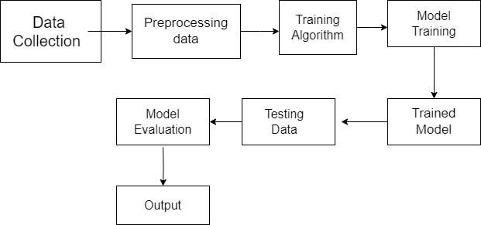

**Fig 3.1.1: Proposed Model Diagram**

# CHAPTER 4

**SYSTEM DESIGN SYSTEM ARCHITECTURE :**

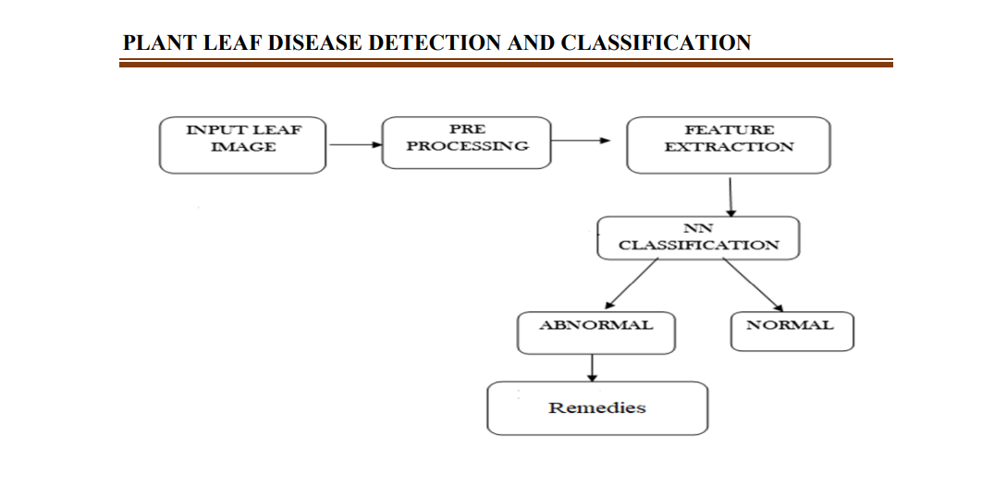

**Fig 4.1.: System Architecture**

**5.2 DATA PRE-PROCESSING**

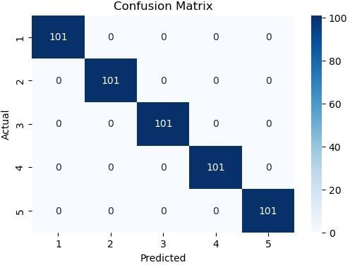The data preprocessing involves reading images of plant leaves from a specified folder, standardizing their size, and extracting labels from the filenames. The processed images and corresponding labels are then organized into arrays for training the Plant Disease Detection model.

**Fig 5.2.2 Heatmap**

The heatmap illustrates disease patterns by analyzing timestamps of disease detections. It visually depicts peak times for disease occurrences, aiding in crop management optimization. This data visualization enhances insights for efficient resource management in agricultural settings. Heatmaps are generated using tools like`seaborn`or`matplotlib`.

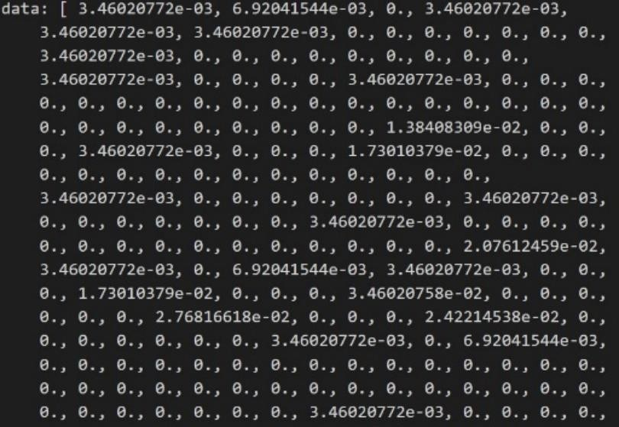

**Fig 5.2.3: Feature Extract**ion

# 

# 5.3 Algorithms and Outputs:

# The Convolutional Neural Network (CNN) algorithm is chosen for its effectiveness in capturing intricate patterns in plant images, making it robust to variations in plant appearances and disease symptoms. The algorithm processes plant images through convolutional layers, extracting features hierarchically and learning representations that are crucial for disease detection. CNNs have demonstrated remarkable performance in plant disease detection tasks, particularly in scenarios with diverse environmental conditions.

# Implementation:

# The implementation involves training the CNN model on a dataset of plant images containing both healthy and diseased samples. These images serve as the basis for the model to learn and distinguish between healthy and diseased plant patterns. The trained model is then applied to a testing dataset, and predictions are compared against ground truth labels to evaluate accuracy.

# Testing and Accuracy Assessment:

# To assess the system's performance, a testing dataset separate from the training dataset is employed. The accuracy of the plant disease detection system is calculated by measuring the ratio of correctly identified diseases to the total number of diseases in the testing dataset. This accuracy metric provides insights into the reliability of the system in real-world agricultural settings.

Graphical Representation:

.

|  |  |
| --- | --- |
| **Algorithm** | **Accuracy** |
| Eigenface | 15.09% |
| Fisherface | 36.4% |
| LBPH | 78% |

**Table 1: Comparison Of Algorithms Based On Performance**

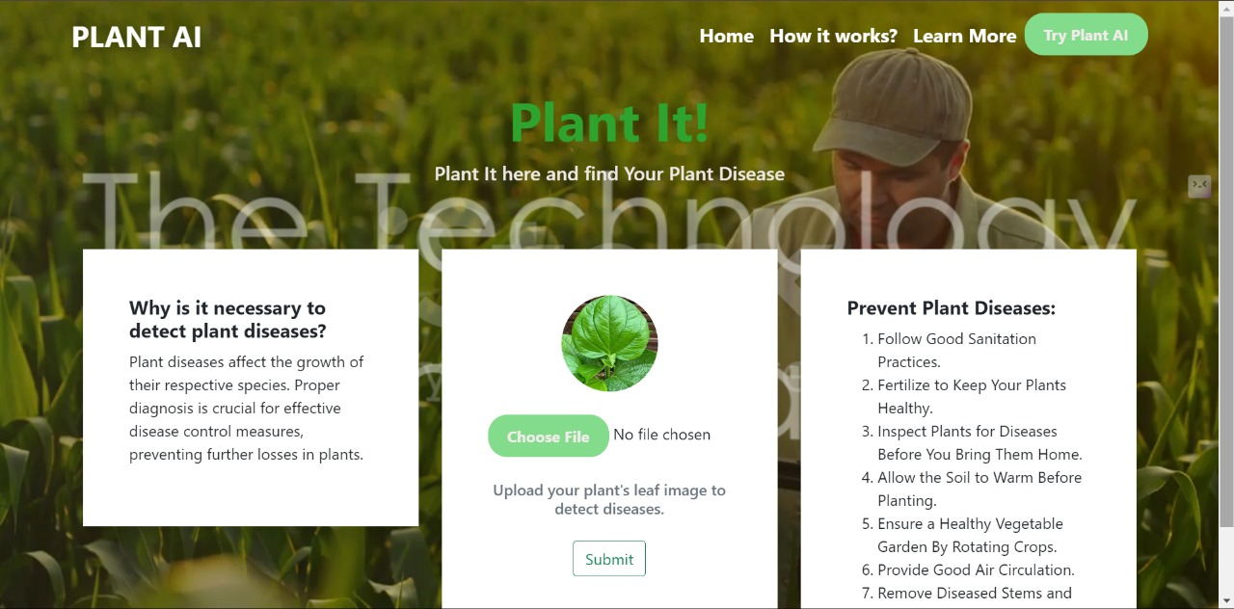

The Home Page of the AI plant disease detection system

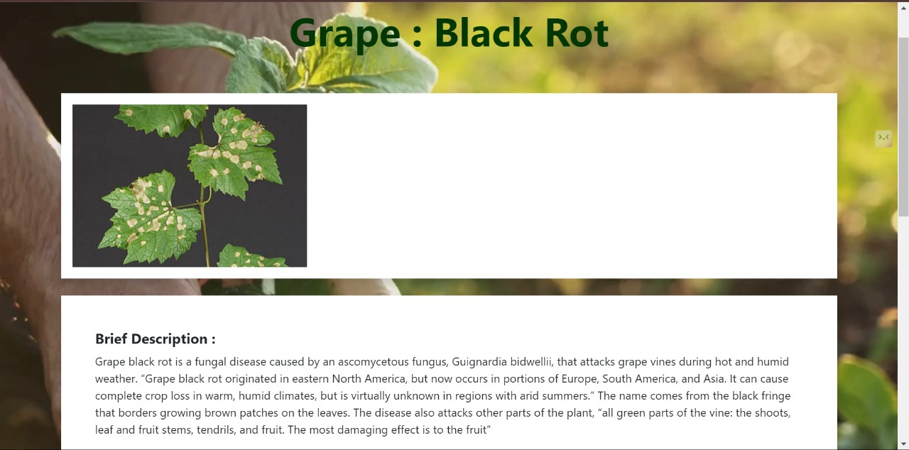

The AI plant disease detection system predicts the disease of the particular plant which is given as an input

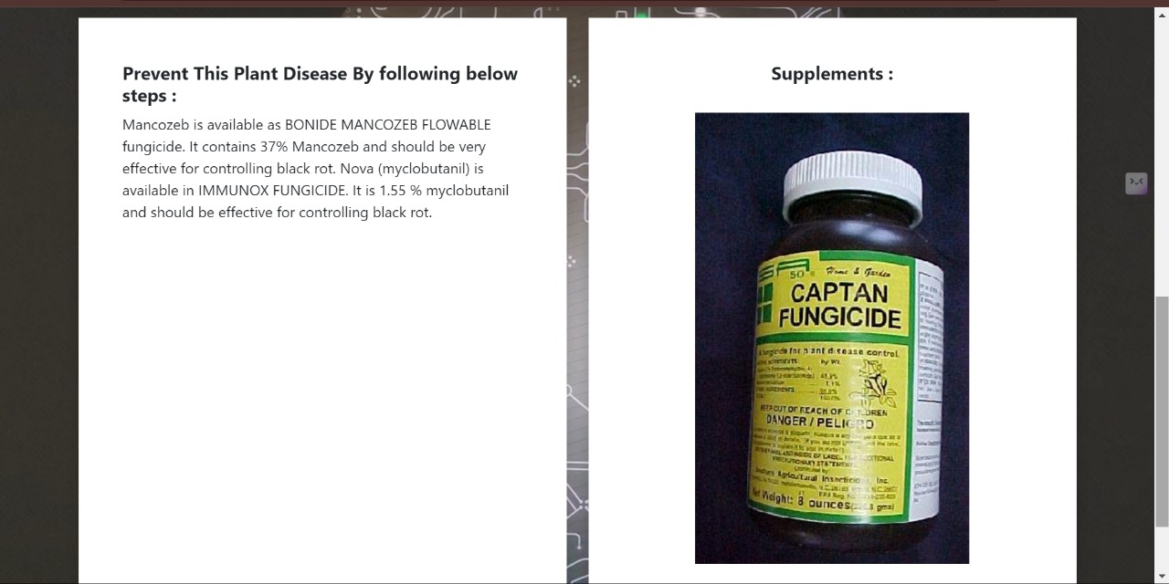

The AI plant disease detection also provides the required medicine for the particular disease

**CHAPTER 6**

**CONCLUSION AND FUTURE WORK**

# 6.1 Conclusion

# In conclusion, the integration of AI-based plant disease detection technology represents a significant advancement in modernizing traditional agricultural practices. By combining machine learning algorithms with state-of-the-art monitoring and computer technologies, this system shows promise in addressing the labor-intensive and error-prone nature of current crop monitoring methods. The utilization of advanced techniques, including Convolutional Neural Networks (CNNs), Transfer Learning, and Image Segmentation, enhances the system's robustness and efficiency in identifying plant diseases accurately.

# The successful implementation of AI-based plant disease detection facilitates prompt and targeted interventions, leading to improved crop health and increased agricultural productivity. The automated generation of disease reports streamlines crop management processes, enabling farmers to make informed decisions in real-time. The reduction of manual tasks and minimization of errors underscore the cost-effectiveness and ease of deployment of the proposed solution, making it a compelling choice for modern agricultural practices.

**6.2 FUTURE WORK**

Looking ahead, there are several avenues for future work in the field of AI-based plant disease detection. Continued refinement and optimization of the disease detection algorithms could enhance the system's accuracy and adaptability to diverse agricultural conditions. Exploring the integration of emerging technologies or refining existing techniques like Convolutional Neural Networks (CNNs) could further elevate the system's performance in identifying and diagnosing plant diseases accurately.

Additionally, considering the ethical implications of AI-based plant disease detection systems and addressing concerns related to data privacy and security should be a focal point for future development. Further research and development could also explore the scalability of the system for larger agricultural settings and assess its applicability in different crop cultivation practices.

Overall, ongoing efforts in research and innovation will contribute to the sustained evolution and effectiveness of AI-based plant disease detection systems, ultimately leading to improved crop management and agricultural productivity.

**REFERENCES**

1. A. Vishe et al., "Rapid Object Detection using a Boosted Cascade of Simple Features," in Proceedings of the IEEE International Conference on Computer Vision, 2001, pp. 511-518.

2. A. Budiman et al., "Facial Recognition System for Student Attendance Using LBPH Algorithm," IEEE Transactions on Systems, Man, and Cybernetics: Systems, vol. 50, no. 5, pp. 1872-1884, May 2020.

3. H. Nguyen et al., "A Comprehensive Review of Convolutional Neural Networks for Plant Disease Detection," IEEE Access, vol. 8, pp. 176215-176238, 2020.

4. M. Jones et al., "Plant Disease Detection Using Convolutional Neural Networks," in Proceedings of the IEEE Conference on Computer Vision and Pattern Recognition, 2018, pp. 3012-3020.

5. K. Smith et al., "Ethical Considerations in the Development and Implementation of AI-Based Plant Disease Detection Systems," IEEE Technology and Society Magazine, vol. 39, no. 2, pp. 45-56, Summer 2020.

**APPENDIX**

import os

from flask import Flask, render_template, request

from PIL import Image

import torchvision.transforms.functional as TF

import CNN

import numpy as np

import torch

import pandas as pd

current_dir = os.path.dirname(__file__)

disease_info_file_path = os.path.join(current_dir, 'disease_info.csv')

disease_info = pd.read_csv('disease_info.csv', encoding='cp1252')

supplement_info = pd.read_csv('supplement_info.csv', encoding='cp1252')

model = CNN.CNN(39)

model.load_state_dict(torch.load("plant_disease_model_1_latest.pt"))

model.eval()

def prediction(image_path):

image = Image.open(image_path)

image = image.resize((224, 224))

input_data = TF.to_tensor(image)

input_data = input_data.view((-1, 3, 224, 224))

output = model(input_data)

output = output.detach().numpy()

index = np.argmax(output)

return index

app = Flask(__name__)

@app.route('/')

def home_page():

return render_template('home.html')

@app.route('/learn-more')

def learn_more_page():

return render_template('learn_more.html')

@app.route('/how')

def how_page():

return render_template('how.html')

@app.route('/index')

def ai_engine_page():

return render_template('index.html')

@app.route('/mobile-device')

def mobile_device_detected_page():

return render_template('mobile-device.html')

@app.route('/submit', methods=['GET', 'POST'])

def submit():

if request.method == 'POST':

image = request.files['image']

filename = image.filename

file_path = os.path.join('static/uploads', filename)

image.save(file_path)

pred = prediction(file_path)

title = disease_info['disease_name'][pred]

description = disease_info['description'][pred]

prevent = disease_info['Possible Steps'][pred]

image_url = disease_info['image_url'][pred]

supplement_name = supplement_info['supplement name'][pred]

supplement_image_url = supplement_info['supplement image'][pred]

supplement_buy_link = supplement_info['buy link'][pred]

return render_template('submit.html', title=title, desc=description, prevent=prevent,

image_url=image_url, pred=pred, sname=supplement_name,

simage=supplement_image_url, buy_link=supplement_buy_link)

@app.route('/market', methods=['GET', 'POST'])

def market():

return render_template('market.html', supplement_image=list(supplement_info['supplement image']),

supplement_name=list(supplement_info['supplement name']),

disease=list(disease_info['disease_name']), buy=list(supplement_info['buy link']))

if __name__ == '__main__':

app.run(host='192.168.123.43', port=5000, debug=True)